Summer Training

# FINAL REPORT

SUBMITTED IN PARTIAL FULFILLMENT OF THE REQUIREMENT FOR

4-Weeks Industrial Training (**TR-102**) At

### Sensation Software Solutions Pvt Ltd Mohali

#### (from 23rd June 2025 to 23rd July 2025)

SUBMITTED BY

Lokesh Kumar

(BTech Computer Science)

CRN: 2315139

URN: 2302594



### Department of Computer Science Engineering GURU NANAK DEV ENGINEERING COLLEGE

**LUDHIANA , INDIA**

**Training Certificate**



## GURU NANAK DEV ENGINEERING COLLEGE,

**LUDHIANA**

#### CANDIDATE'S DECLARATION

I “ **Lokesh Kumar**” hereby declare that I have undertaken one month training “

##### Sensation Software Solutions Pvt. Ltd., Mohali”

during a period from **23rd June** to **23rd July** in partial fulfillment of requirements for the award of degree of B.Tech (Computer Science Engineering) at

GURU NANAK DEV ENGINEERING COLLEGE, LUDHIANA. The work which is being

presented in the training report submitted to Department of Computer Science

Engineering at GURU NANAK DEV ENGINEERING COLLEGE, LUDHIANA is an

authentic record of training work.

Signature of the Student

The one month industrial training Viva–Voce Examination of has been held on

and accepted.

Signature of Internal Examiner Signature of External Examiner

**Abstract**

#### Abstract

##### Title: Summer Training in Cyber Security : Sensations Software Solutions Pvt. Ltd., Mohali Duration: 4 Weeks

This summer training program at Sensation Software Solutions, Mohali, provided me with a

practical foundation in **Cyber Security**, equipping me with essential skills to understand and counter modern digital threats. During the 4-week training, I explored a wide range of topics, including **network security, system vulnerabilities, ethical hacking tools, penetration testing**, and **Linux-based command-line operations**.

The training followed a **hands-on learning approach**, supported by real-time lab simulations and exposure to industry-level tools such as **Kali Linux, Nmap, Wireshark, Metasploit**, and **Burp Suite**. These tools helped me understand how cyber attacks are carried out and how they can be ethically prevented.

The learning environment at Sensation was interactive and supportive, encouraging us to think critically and adopt a **security-first mindset**. I also learned about **information gathering, footprinting, scanning networks, password cracking, and website exploitation**, which strengthened my understanding of offensive and defensive security techniques.

This training served as a crucial step toward building a career in **cybersecurity**, offering me not just theoretical knowledge but practical insight into the mindset of both ethical hackers and malicious actors. I now feel better prepared to handle future challenges in the evolving field of information security.

## Acknowledgement :

I would like to express my sincere gratitude to **Sensation Software Solutions Pvt. Ltd., Mohali** for providing me the opportunity to undertake a four-week summer training in **Cyber Security**.

I am especially thankful to the trainers and mentors at Sensation for their valuable guidance, real-time demonstrations, and constant support throughout the training period.

Their expertise and interactive sessions helped me understand the practical aspects of ethical hacking, penetration testing, and cybersecurity fundamentals.

I extend my heartfelt thanks to my college faculty and training & placement cell for coordinating the program and motivating me to participate in such an industry-oriented training.

Lastly, I would also like to thank my friends and family for their continuous encouragement and support throughout this learning journey.

##### Lokesh Kumar

**B.Tech – Computer Science Engineering**

**Guru Nanak Dev Engineering College , Ludhiana.**

## ABOUT THE COMPANY

**Sensation Solutions** is one of the best Companies, well defined to offer customer-centric B2B, B2C services & indigenous products for various industry verticals such as Digital Services, IT Services, Gaming, Travel, Business Consultancy & Legal Services. We have a team of experts that leaves no stone unturned to provide the best solutions.

In the year 2013, **Sensation Solutions** was born with the aim of empowering local businesses to to expand and register their presence globally. With each passing year, we grew exponentially and the reason behind the tremendous growth, To the point process, our Customer interaction, Development Strategies and of course our dedication to build something amazing par excellence. Today we have reached the stage we are in stands in league of top market leaders in the IT & Digital Services world that specializes in providing the top notch services. You name any IT service, we are able to provide it.



# List of Figures

|  |  |  |
| --- | --- | --- |
| ***Fig No.*** | ***Title*** | ***Page***  ***No.*** |
| ***Fig 1.1*** | *Threats in Information Technology* | *6* |
| ***Fig 1.2*** | *CIA Triad* | *10* |
| ***Fig 1.3*** | *Types of Hackers* | *12* |
| ***Fig 2.1*** | *Basics and Environment Setup* | *19* |
| ***Fig 2.2*** | *Linux Commands Frequently Used in Hacking* | *25* |
| ***Fig 2.3*** | *Wireshark Network Analyzer* | *27* |
| ***Fig 2.4*** | *Steghide Tool* | *31* |

**List of Tables**

|  |  |  |
| --- | --- | --- |
| ***Table***  ***No.*** | ***Title*** | ***Page***  ***No.*** |
| ***Table 1.1*** | *Types of Cyber Threats and Their Descriptions* | *6* |
| ***Table 1.2*** | *Ethical Hacking Terminologies – Part 1* | *10* |
| ***Table 1.3*** | *Ethical Hacking Terminologies – Part 2* | *12* |
| ***Table 1.4*** | *Types of Hackers and Their Characteristics* | *19* |
| ***Table 2.1*** | *Linux Commands Frequently Used in Hacking* | *25* |
| ***Table 2.2*** | *Basic Network Protocols and Their Functions* | *27* |
| ***Table 2.3*** | *Comparison Between Virus, Worm, Trojan, and Ransomware* | *31* |
| ***Table 3.1*** | *Tools Used During Training and Their Purpose* | *35* |
| ***Table 3.2*** | *Summary of Practical Tasks Completed by Students* | *40* |

## CHAPTER 1: INTRODUCTION

### Introduction to Information Security

Information security refers to the processes and methodologies which are designed and implemented to protect print, electronic, or any other form of confidential, private, and sensitive information or data from unauthorized access, use, misuse, disclosure, destruction, modification, or disruption. In the modern digital era, the value of data has surged drastically, leading to more targeted and sophisticated cyber attacks. Information security incorporates various strategies to defend data from cybercriminals, natural disasters, and human error. It involves three key principles – confidentiality, integrity, and availability, often known as the CIA triad. Ensuring these aspects are maintained is crucial for the security of an organization’s data assets. The concept of layered security is also important in information security, where multiple layers of protection are applied across hardware, software, network, and human elements to reduce risk. The rise of cloud computing, mobile technologies, and the Internet of Things (IoT) has significantly increased the attack surface, making robust information security more important than ever.

Organizations invest in risk assessment, vulnerability management, secure coding practices, employee training, and continuous monitoring to keep their data safe. This chapter elaborates on the core foundation and significance of securing information in any form.

### Threats in Information Security

Threats in information security refer to potential risks or attacks that can harm data integrity, confidentiality, or availability. Common threats include:

##### Malware: Malicious software like viruses, worms, Trojans that damage or disrupt systems.

* + - **Phishing**: Fraudulent attempts to obtain sensitive information by impersonating trusted sources.
    - **Ransomware**: Malware that locks or encrypts files and demands payment for access.
    - **Social Engineering**: Manipulating individuals into giving confidential information.
    - **Man-in-the-Middle (MITM)**: Intercepting communication between two parties.
    - **Denial of Service (DoS)**: Overloading systems to make them unavailable to users.
    - **SQL Injection**: Inserting malicious SQL code into a query to manipulate databases.
    - **Zero-Day Exploits**: Attacks targeting software vulnerabilities unknown to the vendor.

Understanding these threats is essential to implementing proper defenses and ensuring information remains secure.

**Figure 1.1**

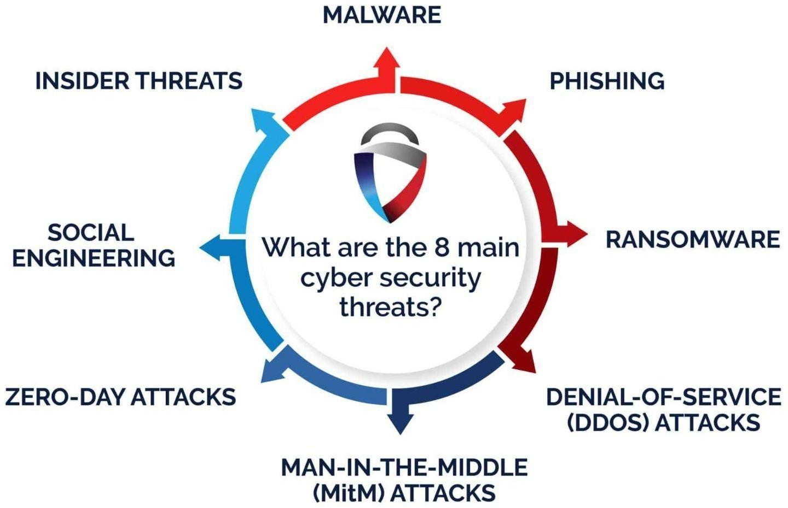

#### Introduction to Cyber Security

Cybersecurity is the practice of protecting systems, networks, and programs from digital attacks. These cyberattacks are usually aimed at accessing, changing, or destroying sensitive information; extorting money from users; or interrupting normal business processes. Implementing effective cybersecurity measures is particularly challenging today because there are more devices than people, and attackers are becoming more innovative. Cybersecurity includes multiple layers of protection spread across the computers, networks, programs, or data that one intends to keep safe. In an organization, the people, processes, and technology must all complement one another to create an effective defense from cyberattacks. Common elements of cybersecurity include network security, application security, endpoint security, data security, identity management, and more.

#### CIA Triad

The CIA Triad is a foundational model in information security that stands for Confidentiality, Integrity, and Availability:

* + - **Confidentiality** ensures that sensitive information is accessed only by authorized individuals. Measures such as encryption and access control are used.
    - **Integrity** ensures that data is accurate, complete, and not altered without authorization. Techniques like hashing and checksums help maintain integrity.
    - **Availability** ensures that information and resources are accessible to authorized users when needed. This involves maintaining hardware, performing regular updates, and having backup systems.

Together, these three components form the core principles of any secure system and help guide the implementation of policies and practices in cybersecurity.

##### Figure 1.2

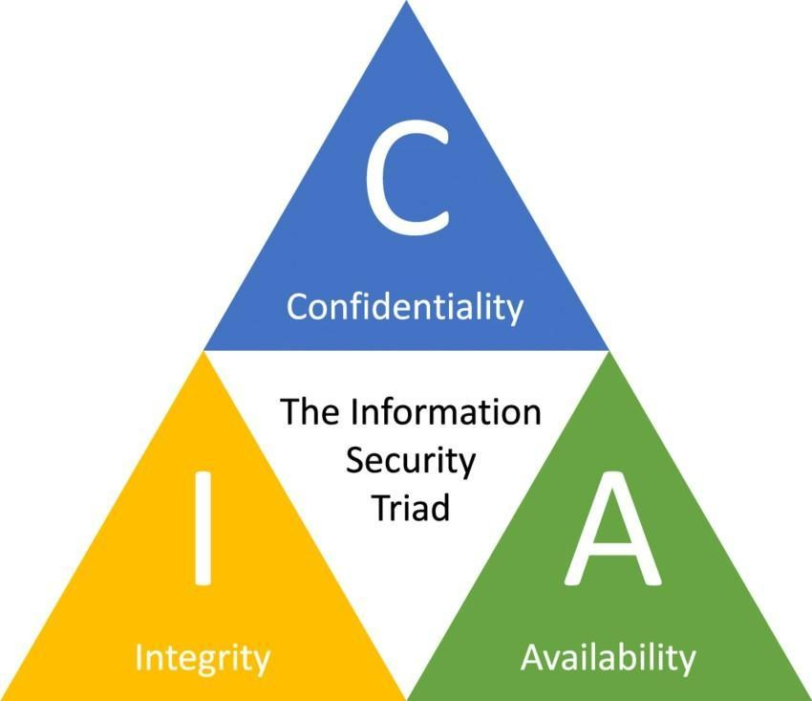

* 1. **Common Terminologies in Ethical Hacking – Part 1** Understanding key terminologies is essential in ethical hacking:
     + **IP Address**: Unique address for identifying a device on the Internet.
     + **Firewall**: A security device that monitors incoming and outgoing network traffic.
     + **Vulnerability**: A weakness that can be exploited by a threat.
     + **Exploit**: A tool or technique used to take advantage of a vulnerability.
     + **Payload**: The part of malware that performs a malicious action. These terms are foundational for beginners in cybersecurity and form the base of ethical hacking practices.

#### Common Terminologies in Ethical Hacking – Part 2

* + - **Penetration Testing**: Simulated cyberattack to find vulnerabilities.
    - **Backdoor**: Hidden method of bypassing normal authentication.
    - **Rootkit**: Malicious software designed to enable unauthorized access.
    - **Trojan Horse**: A type of malware disguised as legitimate software.
    - **Botnet**: A network of infected devices controlled by an attacker. Understanding these terms helps in grasping the methodologies used by both ethical and unethical hackers.

#### What is Cybercrime?

Cybercrime is any criminal activity that involves a computer, network or networked device.

While most cybercriminals use cybercrimes to generate a profit, some cybercrimes are carried out against computers or devices to directly damage or disable them. Others use computers or networks to spread [malware](https://www.techtarget.com/searchsecurity/definition/malware), illegal information, images or other materials. Some cybercrimes do both -- i.e., target computers to infect them with a computer virus, which is then spread to other machines and, sometimes, entire networks.

A primary effect of cybercrime is financial. Cybercrime can include many different types of profit-driven criminal activity, including [ransomware](https://www.techtarget.com/searchsecurity/definition/ransomware) attacks, email and internet fraud, and identity fraud, as well as attempts to steal financial account, credit card or other payment card information.

As cybercriminals might target an individual's private information or corporate data for theft and resale, it's especially important to [protect backup data](https://www.techtarget.com/searchdatabackup/tip/Ten-ways-you-can-make-your-data-backups-more-secure).

* 1. **What is Hacking?**

A commonly used hacking definition is the act of compromising digital devices and networks through unauthorized access to an account or computer system. Hacking is not always a malicious act, but it is most commonly associated with illegal activity and data theft by cyber criminals.

But what is hacking in a cyber security context?

Hacking in cyber security refers to the misuse of devices like computers, smartphones, tablets, and networks to cause damage to or corrupt systems, gather information on users, steal data and documents, or disrupt data-related activity.

A traditional view of hackers is a lone rogue programmer who is highly skilled in coding and modifying computer software and hardware systems. But this narrow view does not cover the true technical nature of hacking. Hackers are increasingly growing in sophistication, using stealthy attack methods designed to go completely unnoticed by cybersecurity software and IT teams. They are also highly skilled in creating [attack](https://www.fortinet.com/resources/cyberglossary/attack-vector) [vectors](https://www.fortinet.com/resources/cyberglossary/attack-vector) that trick users into opening malicious attachments or links and freely giving up their sensitive personal data.

As a result, modern-day hacking involves far more than just an angry kid in their bedroom. It is a multibillion-dollar industry with extremely sophisticated and successful techniques.

* 1. **What is Ethical Hacking?**

Ethical hackers follow a strict code of ethics to make sure their actions help rather than harm companies. Many organizations that train or certify ethical hackers, such as the

International Council of E-Commerce Consultants (EC Council), publish their own formal written code of ethics. While stated ethics can vary among hackers or organizations, the general guidelines are:

Ethical hackers get permission from the companies they hack: Ethical hackers are employed by or partnered with the organizations they hack. They work with companies to define a scope for their activities including hacking timelines, methods used and systems and assets tested. Ethical hackers don't cause any harm: Ethical hackers don't do any

actual damage to the systems they hack, nor do they steal any sensitive data they find. When white hats hack a network, they're only doing it to demonstrate what real cybercriminals might do. Ethical hackers keep their findings confidential: Ethical hackers share the information they gather on vulnerabilities and security systems with the company—and only the company. They also assist the company in using these findings to improve network defenses.

Ethical hackers work within the confines of the law: Ethical hackers use only legal methods to assess information security. They don't associate with black hats or participate in malicious hacks.

#### Types of Hackers

Hackers are individuals with deep knowledge of computer systems, programming, and networking, who use their skills to find and exploit vulnerabilities. However, not all hackers have malicious intent. Based on their objectives and the nature of their actions, hackers are generally categorized into the following main types:

1. **White Hat Hackers:** Also known as ethical hackers, white hat hackers use their skills to help organizations identify and fix security vulnerabilities. They often work as cybersecurity professionals or consultants and perform penetration testing to improve system defenses. Their work is legal and constructive.
2. **Black Hat Hackers**: These are malicious hackers who exploit systems for personal gain, financial theft, or disruption. Black hat activities include data

breaches, malware attacks, and ransomware deployment. They operate illegally and are considered a serious threat to cybersecurity.

1. **Grey Hat Hackers:** Grey hats fall between white and black hats. They may find vulnerabilities in a system without permission and disclose them publicly or to the affected organization. Although their intentions might not be harmful, their actions are often unauthorized and fall in a legal gray area.
2. **Script Kiddies:** These are amateur hackers who lack deep technical knowledge and rely on existing tools and scripts created by others. Their attacks are often less sophisticated but can still cause significant damage if aimed at weakly protected systems.
3. **Hacktivists:** Hacktivists use hacking as a form of political or social protest. They aim to raise awareness, disrupt organizations or governments, and promote a specific agenda. Groups like Anonymous are known for such activities.
4. **Blue Hat Hackers:** Blue hats are individuals who test software and systems for vulnerabilities before they are released. Sometimes, the term is also used for those who seek revenge through hacking without being part of a larger community.
5. **Red Hat Hackers**: Often considered the vigilantes of the hacking world, red hat hackers aim to fight black hat hackers by any means necessary, including aggressive retaliation or hacking back into malicious systems.

**Figure 1.3**

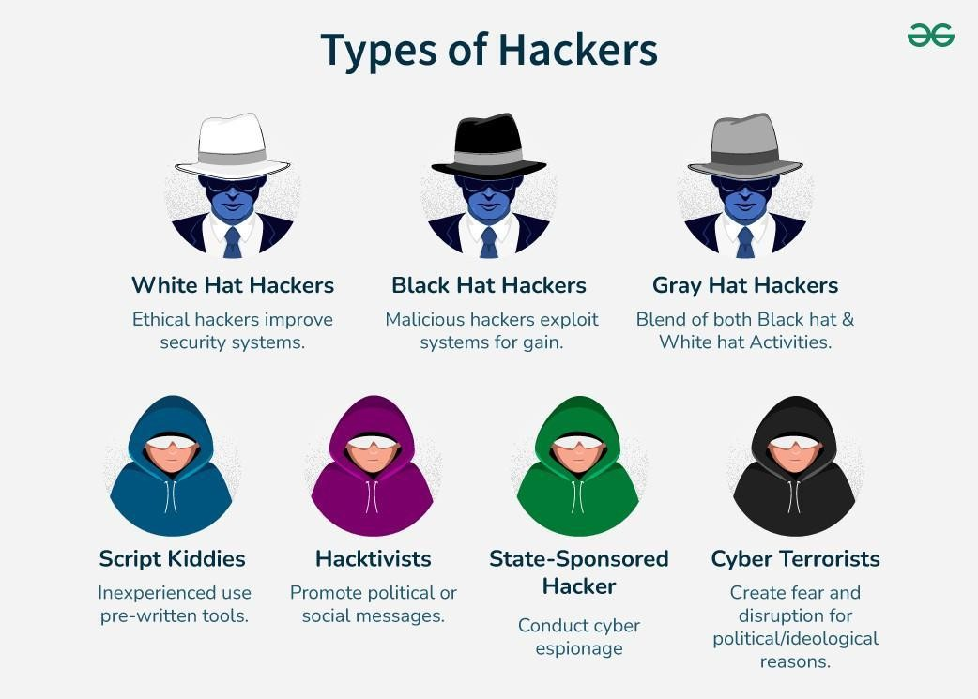

## CHAPTER 2: TRAINING WORK UNDERTAKEN

#### Basics and Environment Setup

During the training at ThinkNEXT Technologies Pvt. Ltd., the initial focus was on setting up the required software and understanding the training environment. This included installing virtual machines such as VMware or VirtualBox, downloading Kali Linux, and setting up penetration testing tools. The basic configuration of these platforms was covered thoroughly. Students learned how to use command-line tools, text editors, and terminal operations which are critical for cybersecurity professionals. The environment setup helped build a strong foundation for practical ethical hacking activities.

##### Figure 2.1

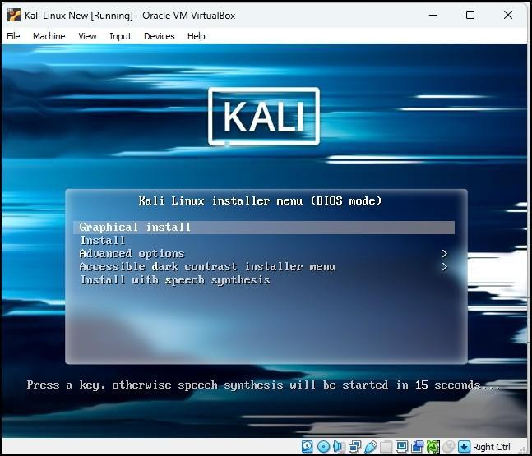

* 1. **Linux Essentials :** Linux is the backbone of ethical hacking. Trainees were introduced to Linux fundamentals such as directory structure, file system, user management, permissions, and basic terminal commands. Commands like ls, cd,

chmod, mkdir, nano, and sudo were explained and practiced. Understanding these commands is crucial because most hacking tools are run on Linux distributions, especially Kali Linux. Students also learned shell scripting basics to automate tasks. Mastery of Linux enabled the participants to interact with system files, run hacking scripts, and customize their toolset.

#### Figure 2.2

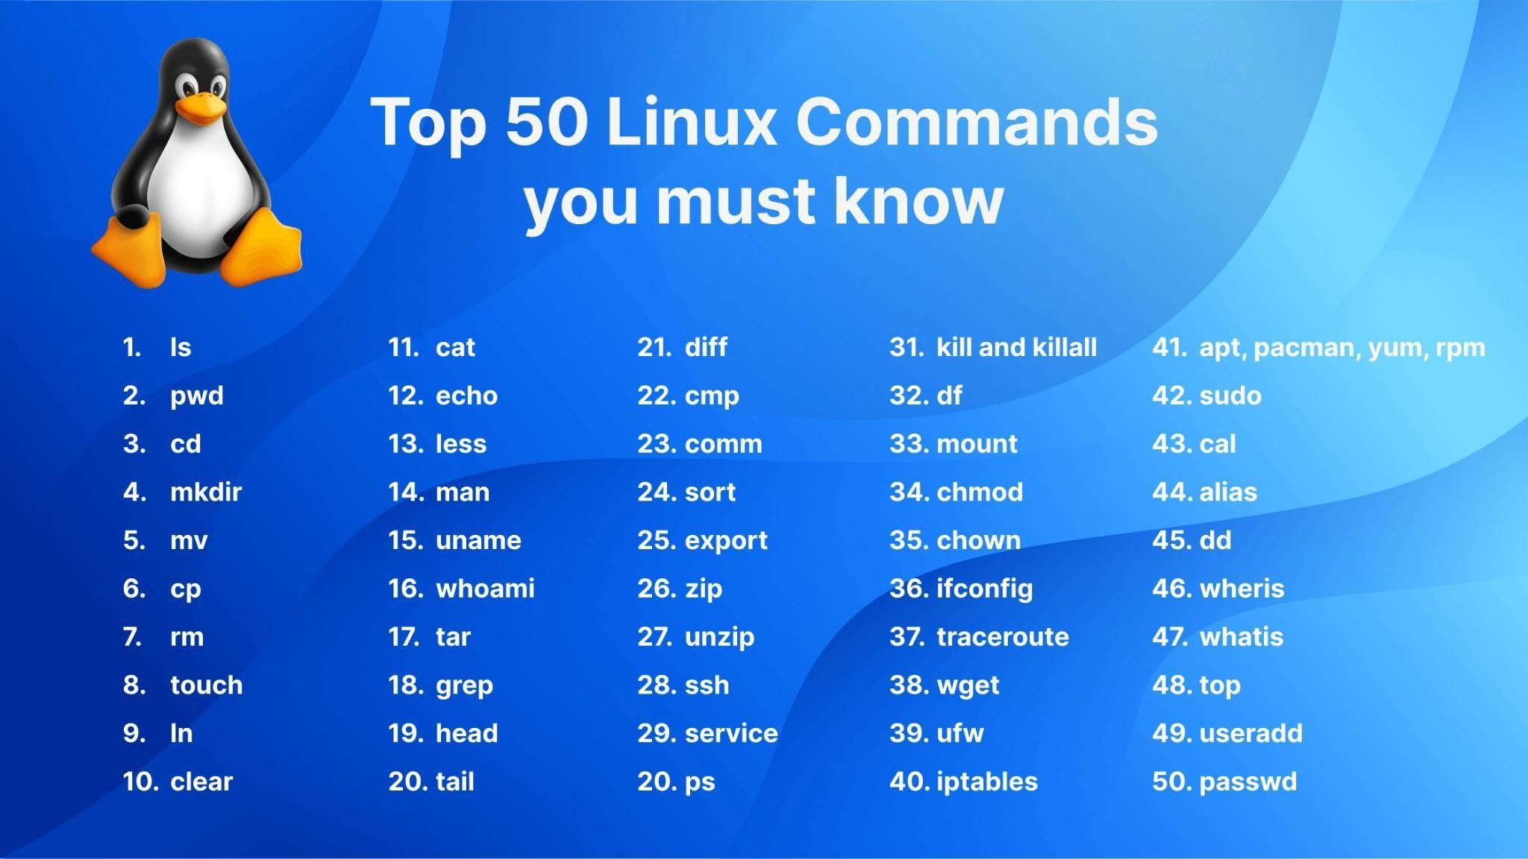

* 1. **Computer Networking :** This section of training covered the fundamentals of computer networking which is essential for ethical hacking. Key concepts like IP addressing (IPv4/IPv6), subnetting, MAC addresses, ports, and protocols (TCP/IP, UDP, ICMP) were explained. Tools like Wireshark were introduced for network packet analysis. Network devices such as routers, switches, and firewalls were discussed. The training also explained how data is transmitted over networks, focusing on concepts like DNS,

DHCP, and NAT. Trainees learned how to identify vulnerabilities in network structures and sniff network traffic securely.

#### Figure 2.3

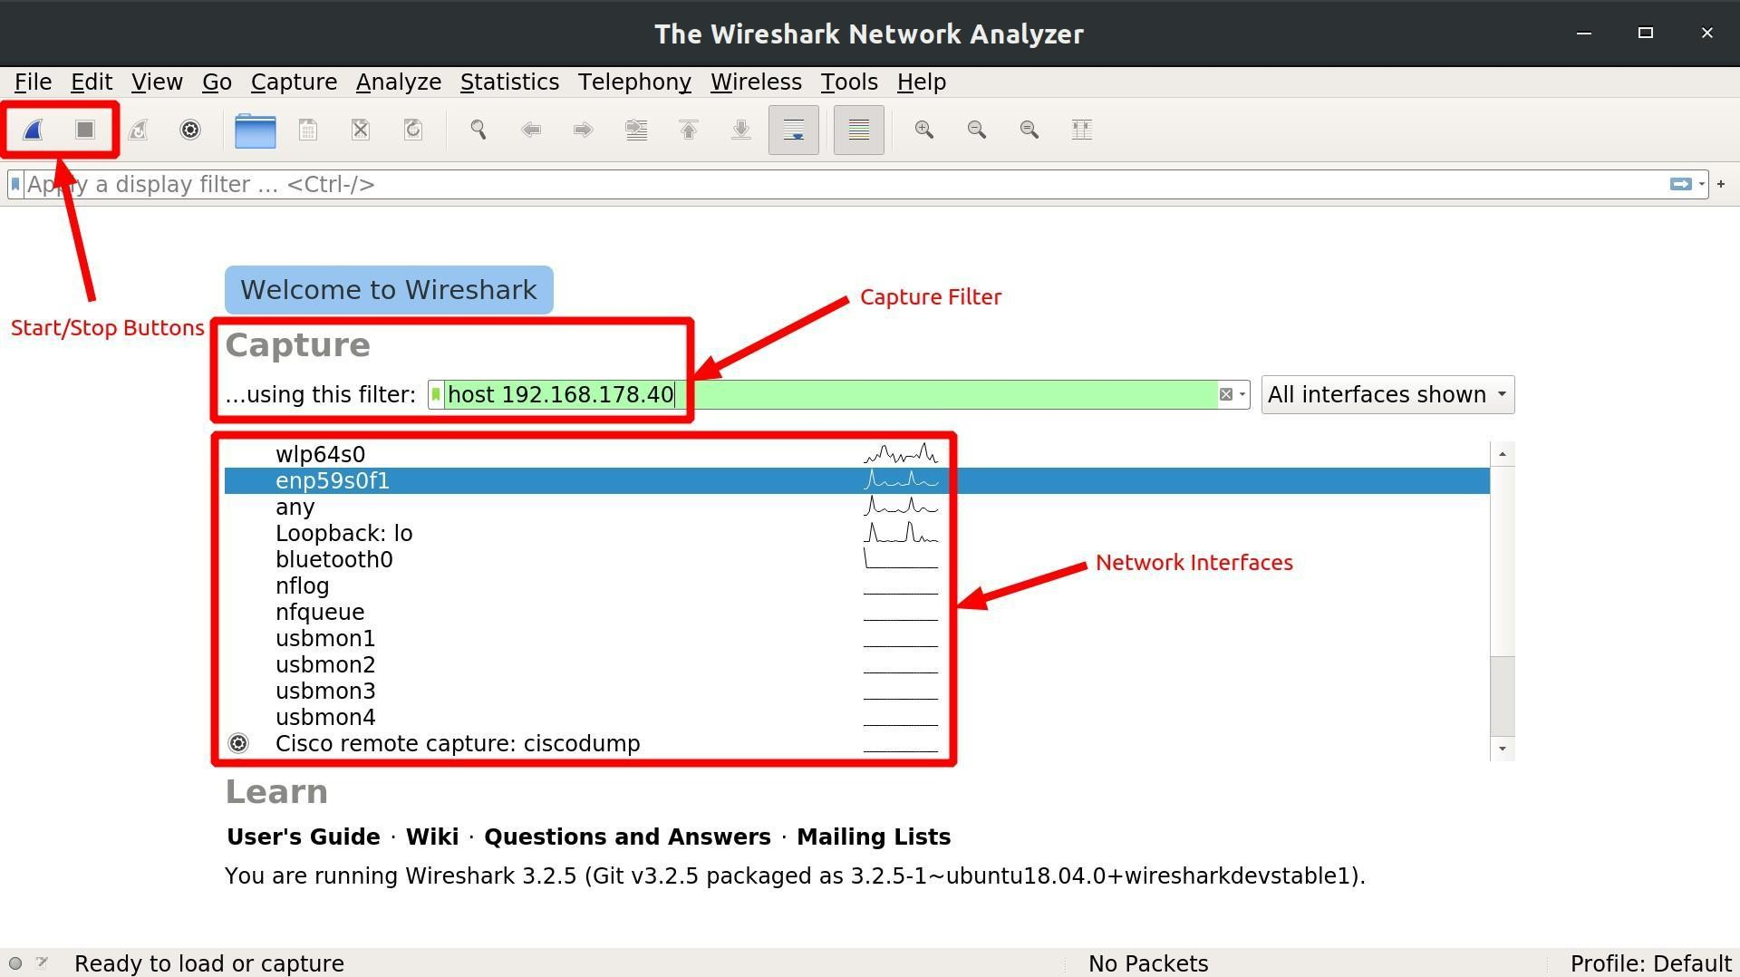

* 1. **Batch File Programming :** Batch file programming was introduced to automate routine tasks on Windows systems. Students learned how to create .bat files to execute commands like opening files, creating directories, and running system operations. Basic batch file syntax, control flow statements (if, goto, for), and file manipulation were taught. This skill is useful in cybersecurity to automate penetration testing activities or system reconnaissance.

#### Malware, Steganography & Phishing :

In the final stages of training, students explored real-world attack vectors. They learned about different types of malware such as viruses, worms, Trojans, ransomware, and spyware. In steganography, tools like Steghide were used to hide messages or data within images or audio files. Phishing tactics were explained with examples, and students were taught to identify suspicious emails and clone web pages. Techniques to simulate phishing attacks were demonstrated, along with ways to detect and report them effectively.

**Figure 2.4**

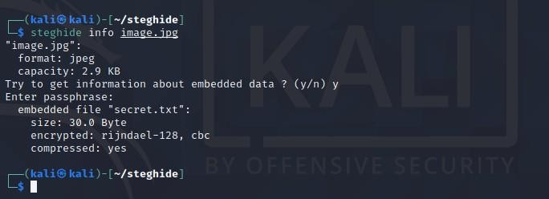

## CHAPTER 3 — RESULTS AND DISCUSSION

#### Practical Outcomes

The four-week internship delivered measurable, hands-on outcomes that transformed theoretical cybersecurity concepts into applied skills. Trainees completed carefully scaffolded lab exercises and small projects that required them to plan, execute, record and reflect on security tasks. Key practical outcomes included:

* + - **Command-line proficiency on Kali Linux:** Trainees progressed from basic navigation (ls, cd, cat) and file permissions to using grep, awk, sed, ssh, scp, and scripting small automation tasks. By week four most students could create and run simple bash scripts to automate repetitive tasks (e.g., bulk scanning and logging).
    - **Network reconnaissance and scanning:** Students used nmap to discover hosts, enumerate open ports, and identify services and versions. They learned to interpret nmap outputs, distinguish between TCP/UDP scans, and use nmap scripts (NSE) for basic vulnerability checks. Scan outputs were saved as XML/grepable files and parsed for reporting.
    - **Traffic capture and protocol analysis:** Using Wireshark and tcpdump, trainees captured live traffic in isolated lab networks and analyzed protocols (ARP, DHCP, DNS, HTTP, TLS). Exercises included following TCP streams, identifying unencrypted credentials in HTTP traffic, and recognizing malformed packets indicative of reconnaissance.
    - **Web application testing using Burp Suite and manual techniques:** Students configured browsers to route traffic through Burp, intercepted and modified requests, and performed vulnerability checks for reflected XSS and basic SQL-injection patterns. Simple workflow automation (Burp Intruder for fuzzing) and use of the repeater were practiced to validate exploitability.
    - **Social engineering simulation and phishing awareness:** Under clear ethical guidelines and using only consenting test accounts, the cohort designed and executed phishing simulations to measure click and report rates. This practical exposed trainees to campaign setup, email construction, and basic tracking/analytics while reinforcing responsible disclosure and legal boundaries.
    - **Steganography and data hiding:** With tools such as steghide and manual inspection techniques, students embedded and extracted hidden payloads within media files. Exercises emphasized detection methods, file metadata analysis, and how steganography can be used in data exfiltration.
    - **Documentation and reporting skills:** Each practical activity concluded with evidence collection—screenshots, logs, packet captures, and vulnerability write-ups. Trainees produced short remediation reports indicating risk, reproduction steps, and suggested fixes. These reports mirrored industry expectations for pentest deliverables.

### Observations

Throughout the internship, several patterns and learning trajectories were observed that inform both pedagogical practices and curriculum improvements.

##### Learning Curve & Adaptation

* + - **Week 1 (Onboarding & Fundamentals):** The majority of students struggled with Linux fundamentals and command-line syntax. Common issues were path misunderstandings, permission errors, and accidental file overwrites. Hands-on pairing and live debugging sessions accelerated recovery.
    - **Week 2 (Tools Introduction):** Students became comfortable with individual tools in isolation—running nmap, capturing traffic with Wireshark, or intercepting with Burp. They needed guidance in correlating outputs across tools.
    - **Week 3 (Integrated Tasks):** Trainees began chaining tools (e.g., reconnaissance with nmap → capture suspicious traffic → analyze in Wireshark). Problem solving and independent investigation improved markedly.
    - **Week 4 (Project & Reporting):** Confidence peaked as students completed mini-projects and produced consolidated reports. Group collaboration and peer reviews further improved quality of output.

#### Common Skill Gaps

* + - **Networking fundamentals:** Some trainees lacked a deep understanding of TCP/IP stack behavior which initially limited their ability to diagnose complex packet flows.
    - **Scripting proficiency:** While many could run scripts, fewer could author robust scripts. This limited automation potential.
    - **Ethical and legal nuance:** Although discussed repeatedly, students sometimes needed reinforcement on the legal boundaries of scanning/penetration—especially regarding scanning intensity and handling of sensitive data.

#### Behavioral and Educational Observations

* + - **Practice beats theory:** Students who spent extra time in the lab (beyond scheduled hours) progressed faster. The “trial-error-learn” loop proved essential.
    - **Pair programming accelerates learning:** Group troubleshooting and paired labs helped struggling students and improved retention.
    - **Documentation habit:** Regular logging and short write-ups improved students’ ability to communicate technical findings clearly.

### Tool Demonstrations and Snapshots

The training emphasized a small set of core tools and workflows; below are representative demonstrations and the kinds of snapshots documented in the appendix.

#### Tools Demonstrated

* + - **Nmap (Network Mapper):**
      * Typical commands used: nmap -sS -sV -p- target, nmap -A -T4 target, nmap

--script vuln target.

* + - * Students learned to interpret banner results and prioritize services for further testing.
    - **Wireshark / tcpdump:**
      * Packet capture strategies: capture filters vs display filters, following TCP/UDP streams.
      * Exercises included identifying HTTP Basic Auth leaks, DNS tunneling indicators, and ARP spoofing attempts.
    - **Burp Suite (Community Edition):**
      * Interception, request tampering, and manual exploitation for XSS / SQLi.
      * Use of Repeater and Intruder to validate inputs and fuzz common parameters.
    - **Steghide / Metadata Tools:**
      * Embedding text into JPEG/WAV, extracting hidden payloads, and using exiftool to inspect metadata.

### Limitations

While the internship provided strong foundational exposure, several limitations constrained the depth and breadth of activities:

* + - **Time Constraints:** A four-week period limited the ability to perform deeper, multi-stage penetration tests or post-exploitation analysis. More advanced topics (e.g., exploit development, reverse engineering) require longer dedicated modules.
    - **Diverse Skill Levels:** Heterogeneous prior knowledge in the cohort required instructors to balance pacing—some students found sessions slow, others found them fast. Future batches would benefit from a short pre-assessment and basic preparatory module.
    - **Tool Licensing & Features:** Use of community/free editions (e.g., Burp Community) restricted some automated capabilities. Commercial tools or extended lab time could expose students to more advanced automation and scanning features.
    - **Ethical Testing Scope:** For legal and ethical safety, external network tests were prohibited; all activities were isolated to controlled lab environments. This protected stakeholders, but reduced exposure to real-world internet-scale factors (e.g., ISP behavior, rate-limiting).
    - **Limited Scripting & Automation Practice:** Although scripting was introduced, the curriculum did not allocate enough hours for each trainee to build production-quality automation scripts, which is an important skill in professional settings.

### Discussion & Recommendations

The internship succeeded in imparting practical cybersecurity skills and generating measurable trainee progress. To enhance future programs:

1. **Pre-course Preparation:** Offer a short primer on Linux and networking to bring participants to a common baseline.
2. **Longer Duration or Modular Follow-up:** Extend the course or provide follow-up modules (4–8 weeks) focusing on advanced topics—automation, exploit development, and incident response.
3. **Project-Based Assessment:** Replace some lab exercises with longer mini-projects that require full lifecycle work (recon → exploitation → reporting).
4. **Tool Access:** Where feasible, provide licensed versions of selected tools (or cloud-based equivalents) so students can experience industry workflows.
5. **Ethics & Legal Frameworks:** Strengthen the legal/ethical component with case studies, policy drafting exercises, and responsible disclosure simulations.
   1. **Conclusion of Chapter**

The results derived from the four-week internship program conclusively demonstrate that a **balanced and structured approach**, integrating both **theoretical instruction** and **supervised, hands-on practical sessions**, is highly effective in developing a strong foundation in **cybersecurity** . The training methodology at *Sensation Software Solutions Pvt. Ltd.* was carefully designed to gradually build students’ confidence—from basic conceptual understanding in the first week to advanced tool implementation and project work in the final week. This systematic approach allowed trainees to steadily progress from beginners with minimal exposure to cybersecurity to individuals capable of performing

real-world security assessments in controlled environments.

Through regular practice, participants not only enhanced their **technical proficiency** but also developed crucial **analytical, observational, and problem-solving skills** required in the cybersecurity domain. The continuous exposure to real-world tools such as **Kali Linux, Nmap, Wireshark, Burp Suite, and Steghide** provided them with industry-relevant skills and confidence to analyze systems, detect vulnerabilities, and suggest appropriate countermeasures. By performing these tasks under supervision, students learned the importance of **ethical responsibility, safety protocols, and adherence to legal frameworks**, which are essential attributes of professional ethical hackers.

The **mentorship-driven environment** and **peer collaboration** also played a vital role in the success of the program. Working together on shared exercises fostered teamwork, discipline, and adaptability—qualities that are as important as technical expertise in the cybersecurity industry. Regular feedback sessions and interactive discussions enabled students to clarify doubts, reinforce concepts, and continuously refine their skills.

Despite certain limitations—such as restricted time for deep penetration testing and varying prior experience levels—the training’s outcomes were highly positive. The structured mix of **lectures, guided demonstrations, lab experiments, and independent tasks** ensured holistic learning and engagement. Addressing the identified constraints through extended project durations, advanced scripting modules, and inclusion of simulated real-world challenges will further enhance the depth and quality of future training iterations.

In conclusion, this internship successfully laid the **foundation for practical cybersecurity competence**, cultivated **a responsible ethical hacking mindset**, and provided **a clear pathway for continuous learning**. The overall impact was not limited to technical knowledge but also extended to personal and professional growth—preparing students to take their next steps confidently into the world of cybersecurity research, defense, and innovation.

## CHAPTER 4: CONCLUSION AND FUTURE SCOPE

#### Conclusion

The **four-week summer training program on Cyber Security** at *Sensation Software Solution Pvt. Ltd.*, Mohali, proved to be a highly enriching and transformative learning experience for all participants. It successfully bridged the gap between classroom learning and practical industry exposure, providing students with both theoretical foundations and practical, hands-on experience in the fast-growing field of cybersecurity.

Throughout the training, participants explored multiple dimensions of **information security**, including the fundamental principles of confidentiality, integrity, and availability — collectively known as the **CIA Triad**. The training delved deep into the understanding of **cyber threats**, **attack vectors**, and the **defensive mechanisms** required to secure modern systems and networks.

Students were introduced to the **core areas of ethical hacking**, including **network reconnaissance**, **vulnerability scanning**, **penetration testing**, **social engineering**, **phishing simulations**, and **malware analysis**. By using real-world tools and performing simulations in a controlled lab environment, participants were able to gain practical exposure to how cyberattacks occur and how they can be prevented.

A major highlight of the internship was the focus on **Linux fundamentals**, as Kali Linux served as the primary operating system for executing penetration testing tasks. Students learned command-line operations, file management, and user permissions, which are vital skills for ethical hackers and cybersecurity analysts.

In addition, the training introduced participants to **Wireshark for network packet analysis**, **Nmap for port scanning and network mapping**, **Burp Suite for web application testing**, and **Steghide for data concealment and retrieval** — tools widely recognized and used by professionals across the cybersecurity industry.

The training’s structure — combining **lectures, live demonstrations, and project-based learning** — ensured a balanced learning curve. Each week built upon the previous one, starting with basic concepts and gradually progressing toward complex real-world applications. This incremental approach allowed students to gain confidence and proficiency over time.

Another major outcome of this internship was the improvement in **problem-solving skills, analytical thinking, and documentation ability**. Every task or project required detailed analysis, report writing, and proper evidence collection through screenshots and logs. This practice not only improved technical documentation skills but also emphasized the professional reporting standards expected in cybersecurity audits and penetration testing reports.

Beyond technical skills, the internship fostered **a mindset of responsibility, discipline, and ethical awareness**. Students learned that ethical hacking is not merely about “breaking into systems” but about **safeguarding information**, **identifying vulnerabilities before malicious hackers do**, and **upholding ethical and legal boundaries**. The training reinforced the importance of acting responsibly while testing, following proper permissions, and adhering to cybersecurity laws such as the *Information Technology Act (2000)*.

Overall, this training acted as a **stepping stone into the world of cybersecurity**, instilling a deeper curiosity and a lifelong learning attitude among participants. It enabled them to see security not as a single domain but as an integral part of every modern technology — from networks and cloud systems to applications and IoT devices.

In conclusion, the internship at Sensation laid a **solid technical foundation**, nurtured **professional ethics**, and built a **security-first mindset** — all essential attributes for anyone aspiring to build a career as a cybersecurity or ethical hacking professional.

#### Future Scope

Cybersecurity is a **continuously evolving domain**, influenced by rapid advancements in technology, increased connectivity, and the constant emergence of new cyber threats. While this internship provided a strong foundation in ethical hacking, it represents only the **beginning of a much broader journey** into the field. Continuous learning, experimentation, and adaptation are essential for any cybersecurity aspirant.

The future scope for students who completed this training can be expanded in several directions:

#### Advanced Penetration Testing

After mastering the basics of scanning and reconnaissance, learners can move toward **advanced exploitation and post-exploitation techniques** using tools like **Metasploit Framework**, **Empire**, and **Cobalt Strike (demo labs)**. These allow professionals to simulate real-world attack scenarios in controlled lab environments and understand privilege escalation, lateral movement, and persistence mechanisms.

Practical exposure to **vulnerability exploitation**, **payload creation**, and **reporting remediation strategies** will deepen students’ understanding of professional penetration testing workflows.

#### Web Application Security

Given the rise of online platforms, **web security** has become a top priority for organizations worldwide. Students can extend their knowledge by exploring the **OWASP Top 10 vulnerabilities**, such as **SQL Injection**, **Cross-Site Scripting (XSS)**, **Insecure Deserialization**, and **Broken Authentication**.

Hands-on experience using tools like **Burp Suite Professional**, **OWASP ZAP**, **SQLMap**, and **DirBuster** can help students learn how attackers exploit web vulnerabilities and how developers can secure applications through proper input validation, sanitization, and secure coding practices.

#### Cloud Security

As most businesses transition to **cloud-based infrastructures** such as AWS, Azure, and Google Cloud, understanding **cloud security principles** has become essential. Students can explore topics like **Identity and Access Management (IAM)**, **encryption in transit and at rest**, **cloud firewalls**, and **shared responsibility models**.

Gaining certifications such as **AWS Security Specialty** or **Google Cloud Security Engineer** can open doors to specialized cloud security careers.

#### Digital Forensics and Incident Response (DFIR)

Another promising area is **digital forensics**, where professionals analyze compromised systems to trace cyber incidents, collect digital evidence, and respond effectively to breaches.

Learning forensic tools such as **Autopsy**, **Volatility**, and **FTK Imager**, along with techniques for analyzing logs, memory dumps, and network traces, can help in detecting attack origins and mitigating future risks. Incident Response (IR) frameworks like **NIST 800-61** provide structured methodologies for dealing with cyberattacks in real-world organizations.

#### Security Certifications and Career Pathways

Pursuing **professional certifications** greatly enhances one’s credibility and employability. Some recommended certifications for students after this training include:

* + **CEH (Certified Ethical Hacker)** — foundational for penetration testers
  + **CompTIA Security+** — strong entry-level certification focusing on security principles
  + **OSCP (Offensive Security Certified Professional)** — advanced certification for real-world exploitation
  + **CISSP** — suitable for those aiming for management and leadership roles in security
  + **CC (Certified in Cybersecurity)** by ISC² — a beginner-friendly certification for foundational knowledge

Each certification validates different skill levels and opens various career paths such as **Security Analyst**, **Penetration Tester**, **SOC Analyst**, **Incident Responder**, or **Information Security Consultant**.

#### Artificial Intelligence and Machine Learning in Cybersecurity

With the advancement of technology, **AI and ML** are increasingly being integrated into cybersecurity systems to automate threat detection and anomaly analysis. Students can explore how **machine learning models** can detect unusual traffic patterns, predict phishing attacks, or identify malware based on behavioral signatures.

This area offers immense research and career opportunities, blending cybersecurity with data science.

#### Continuous Learning and Research

Cybersecurity is not a static field — new threats, exploits, and defenses emerge daily. Therefore, the most critical future scope lies in **continuous self-learning and experimentation**.

Students should:

* + Participate in **Capture The Flag (CTF)** competitions.
  + Join cybersecurity communities and forums like **TryHackMe**, **Hack The Box**, and **Cybrary**.
  + Stay updated with cybersecurity news, threat reports, and blogs.
  + Practice in virtual labs or home setups to reinforce skills consistently.

#### Final Remarks

This internship has been more than just a training program — it served as an **entry point into a challenging yet rewarding profession**. Participants not only learned technical skills but also developed discipline, teamwork, and ethical awareness, all of which are vital in this profession.

The cybersecurity industry offers limitless opportunities, but also demands a mindset of **constant vigilance, adaptability, and moral responsibility**.

As the world moves toward a digital-first future, **the demand for ethical hackers, security analysts, and digital forensics experts** will continue to grow. The knowledge and experience gained through this training will serve as a **strong foundation** for pursuing advanced studies, professional certifications, and successful careers in cybersecurity.

In essence, this internship has **ignited curiosity**, **sharpened analytical skills**, and **instilled a lifelong passion for protecting digital systems**. The journey of a cybersecurity professional is one of **continuous exploration, learning, and innovation**, and this training marks the **first milestone** in that journey.

## REFERENCES

* + 1. William Stallings, *Network Security Essentials: Applications and Standards*, Pearson Education.
    2. Behrouz A. Forouzan, *Cryptography and Network Security*, McGraw Hill.
    3. EC-Council, *Certified Ethical Hacker (CEH) Study Guide*, Wiley Publications.
    4. <https://www.kali.org/> – *Kali Linux Official Documentation*
    5. <https://owasp.org/> – *OWASP: Open Web Application Security Project*
    6. <https://nmap.org/> – *Nmap Official Network Scanning Tool*
    7. <https://www.wireshark.org/> – *Wireshark Network Protocol Analyzer*
    8. <https://www.cybrary.it/> – *Cybersecurity Training Resources*
    9. <https://www.geeksforgeeks.org/> – *Linux Commands and Programming Basics*
    10. https://null-byte.wonderhowto.com/ – *Ethical Hacking Tutorials and Guides*
    11. Sensation Software Solutions Pvt. Ltd., Mohali – *Instructor-led training material and session notes*

## APPENDIX

##### Linux Command Reference Sheet

* + ls, cd, mkdir, rm, chmod, chown, nano, cat, ping, ifconfig, etc.

##### Screenshots and Output Samples

* + Nmap port scan results
  + Wireshark captured packets view
  + Phishing web page simulation snapshot
  + Burp Suite intercepted requests

##### Sample Batch Script

bat CopyEdit

@echo off

echo Welcome to Ethical Hacking Training! mkdir TrainingFiles

cd TrainingFiles

echo This is a demo script > readme.txt

##### Sample Steghide Command

bash CopyEdit

steghide embed -cf image.jpg -ef secret.txt

##### Glossary of Terms

* + Phishing: Fraudulent attempt to obtain sensitive information.
  + Malware: Software designed to disrupt, damage, or gain unauthorized access.
  + Rootkit: Malware that hides its presence or the presence of other malware.
  + Payload: The component of malware that performs malicious action.
  + Exploit: A code or sequence used to take advantage of a vulnerability.